LONG - Qualification

Existing maps:
- Prameny 1989

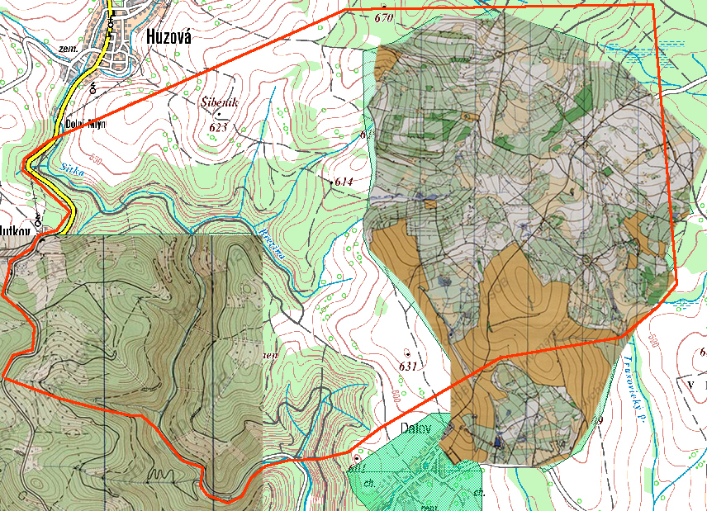

In one part the terrain is gently undulating (not too steep slopes) but with “light mountain-ish” surface. The light green areas on the old map after 20 some years would have been grown but still could be clearly visible on the air photo. It is possible to set really interesting course with change of rhythm but little bit a la Rabštejn WC 91. In the “moderate” part right after start would be necessary to evaluate what would be more beneficial (considering the vegetation density and the surface) go straight or use roads/paths. Other than that typical Moravian race which everybody has done many, many-times.

Special requirements:
- finish the race within inner harmony

Training maps:
- Liščí díra 2001
- Volárna 2001 (jižní část)
- Slunečná 1998
(all maps between Bruntál and Moravský Beroun serve only as example of the terrain in the flat/level part of race area, drawing is “out of focus”)
- Sovinec 2000
- Kukačka 1999 (example of steep valley is close-by)
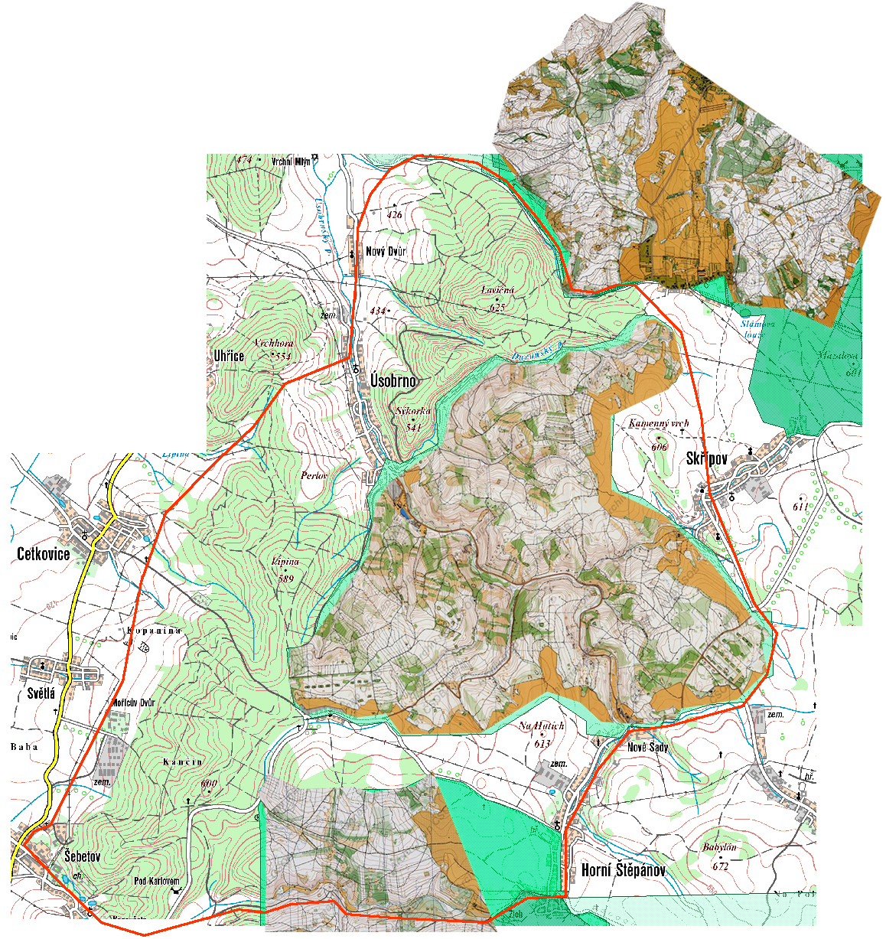
LONG - Final, RELAY

Existing maps:
- Durana (middle) 1989
- Javorník (south)

There are quite serious hills – it could be found hills with elevation 150-200 m. As shows the air photo there are large areas of thick green and clearings/cut blocks especially in the northern part and in the middle.

I would expect (R. Novotny head coach of the Czech team) the long be situated in the north part which offers several deep valleys and could be used for a long-leg variations, however with alternatives of using paths and roads in the valley. It is going to be quite physical race, permitting fast pace on relatively hard surface with numerous steep hills. Navigation would be relatively simple/obvious and predictable. Risks: green outgrown areas, unknown runability through green and cut-blocks, going down small cliffs on slopes (from top), route choice around/over the hills/valleys. Ordinary “Czech” race, perhaps only variegated of critical (principle) route choices along central valleys. Don’t get distressed with “boring” road/path sections (stretches) or “straight”.

Special requirements:
- elite level aerobe capacity (in terrain)
- experience with route choices in similar type of terrain

Relay: rather in the south part of the area and partly in the slopes to the west. Extremely fast on the plateaus, only gently undulating terrain, dense road system. Risks: run in to the slopes from the top, grown out light green areas, decrease of concentration due to extremely fast speed and surrounding pressure (teammates, good result).

Special requirements:
- elite level running capacity
- mental and resistance (stamina) and readability

Training maps:
- Helišova skála (Sloup, high relevant terrain)
- Fiolka (Baldovec, high relevant terrain)
- Hatman (Baldovec)
- Škatulec (Boskovice) - ! trials for Euro Champs
- Ptenské polesí (next to Ptení, WRE race in April)
- Stádlisko (close by Prostějov)
- V Jeřábech (bounds with the race area on south, more flat)
- Drgola (bounds with the race area on north)
- Bělkovice (Brno 2006, Moravian Šternberk, not realy relevant terrain but mapped by Hranička)
- Rakovecké údolí (Brno, previous Bukovinka)
- Veveří (Brno, Czech Champs in ultralong)

SPRINT qualify

Existing maps:
- Prostějov 2002, Prostějov Brněnské předměstí, Prostějov Hvězdárna

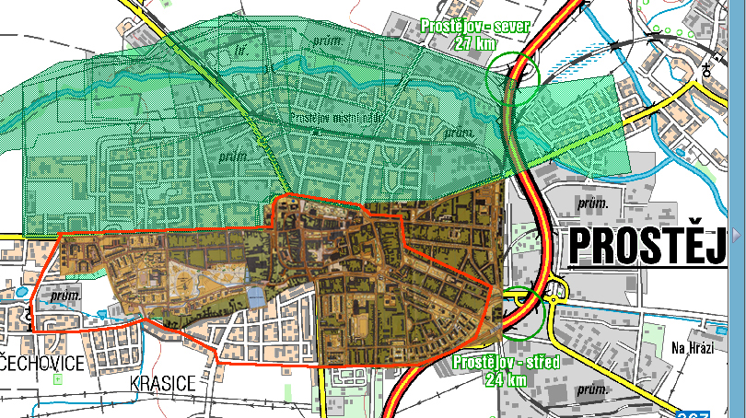

It is quite simple city center and park “all straight”. It is similar to the University WOC 2006 in Košice. Requirement is to have fast enough sprinter-step and no mistake.

Special requirements:
- be relaxed (prior start) and ability to concentrate on you
- running SPEED

SPRINT FINAL

Existing map:
- Olomouc 1998 (PWT)

City race which could be really good (perfect) theoretically prepared for (unfortunately for Czech team because they’re home-TN). The old map is good quality. It is going to be relatively non-insidious, fast city center (downtown) and surrounding flat parks. Rather then puzzling details and continuousness more important would be the route choice and its realization in maximal pace. It would by required to find passageways through rampart (wall) and set a hundreds of routes through blocks in the city centre (it means in European “historical city centre” -TN).

Special requirements
- running SPEED
- theoretical preparation
- keep a cool head

Training Maps:
- sprint maps of Brno
- Pardubice (historical city centre + castle), Kroměříž (it will be a new map for trials for Euro Champ Czech team-TN), Jihlava (similar dispositions, similar city centre), Šumperk (only after WC selections!)
- ! most of sprint maps in Czech Rep is not in ISSOM (it’ll be Kroměříž, perhaps it’d be Šumperk)
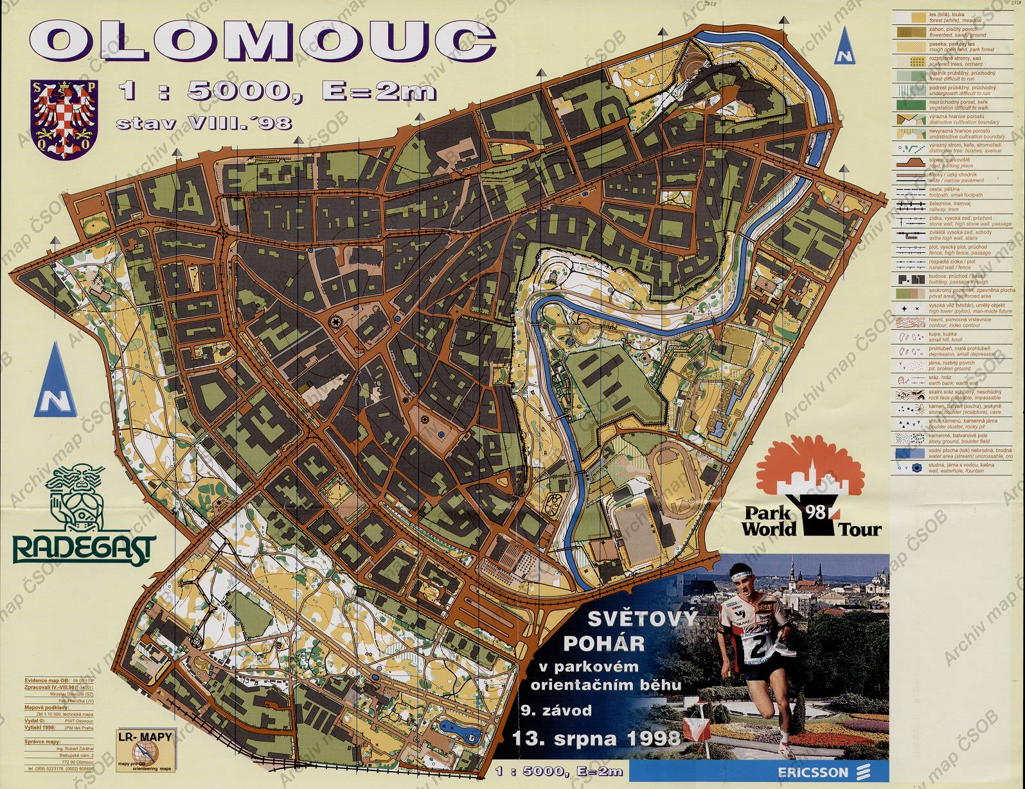
MIDDLE Qualification and Final

Previous maps:
- Rabštejn 1976 (whole area)
- Rabštejn 1987 LOB (most of the map area)
- Žďárský potok 1977

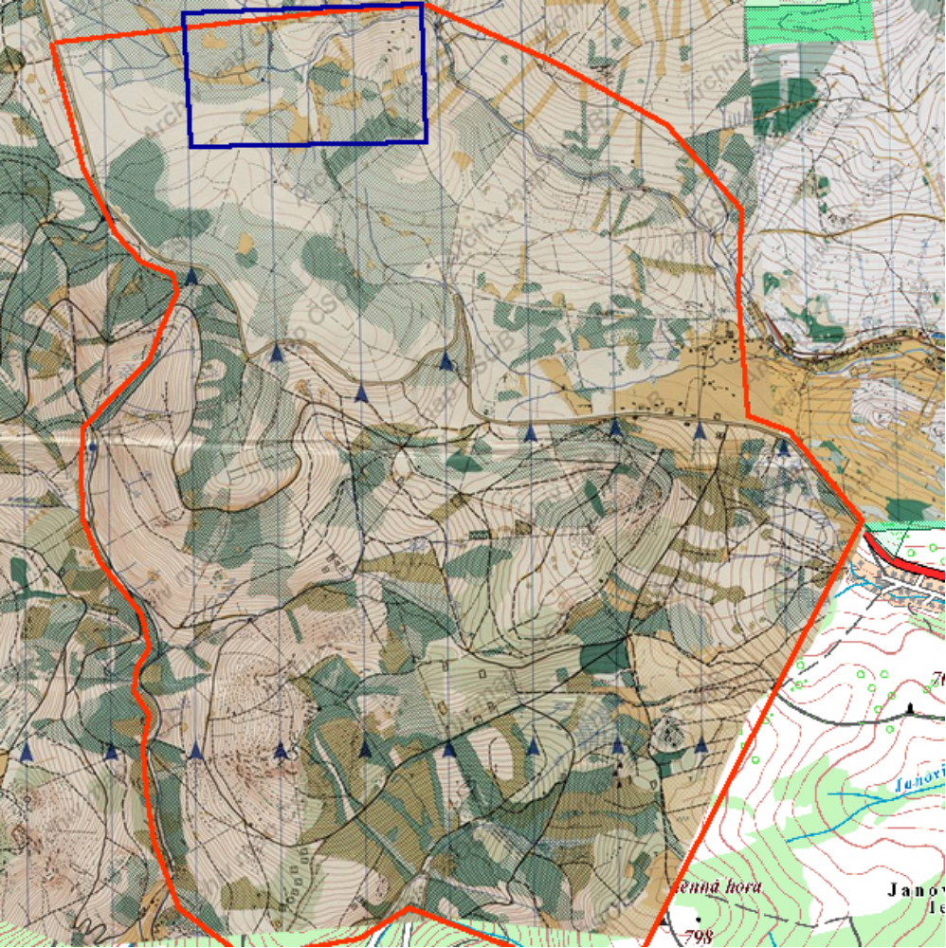

South from the highway is typical “Jesenik Mountain” – long/steep hills traverses, stripes of dense vegetation rocky surface and sporadically scattered boulders. Not as “wild” as in Ludvíkov – more “cultivated” forest. Locally some marshes in slopes might be present. It is possible to adequate prepare for this kind of terrain on maps in close vicinity of Šumperk and Vrbno pod Pradědem.

North of the highway the terrain is more level (flat) like Šumava. On the air photo in this area not a lot of clearings or dense forest can be observed. There will be drainage channels for sure. Stones might be occasionally present in slopes (downhill/uphill). It could be “faster” then the southern part, often straight only with bearing – similar like somewhere in Vysočina or Železné Hory (hills).

The riddle stays the terrain description, where is mentioned "large run-able march/swamp". It may be only in neighbourhood of the Skřítek peat-bog, but which is a natural reserve. Moreover within the embargoed area is only a small part of it. This is an air photo view/enlargement (the blue square from the map on the previous page):

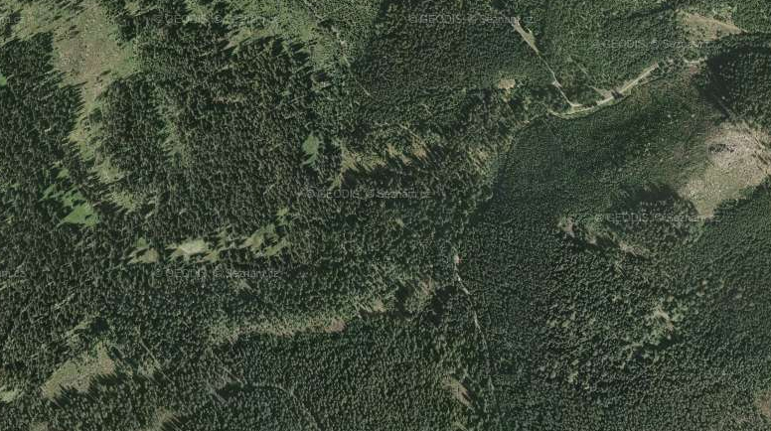

Special requirements
- anaerobe running strength and running technique on uneven, at times stony surface (down the hill too)
- in critical moments to have a plan, keep a cool head and in case of need to slow-down (boulder fields, clearing, depression in a slope...)

Training Maps:
Jeseníky moutains:
- Žďárský potok 1993 (right next to the area requires double check with OC (organisation Comitee-TN) if it is possible!) (I don’t think anybody other that Czech team gets the permission-TN)
- Ruský hřbitov (Czech Long Champ, terrain and map, Rejvíz)
- Sviní hora (Vojtíškov, A-meet 2005)
- Ludvíkov 2007 (Vrbno, rather lower passages)
- Dlouhá voda (next to Krnov, B-meet 2006, north part with creeks)
- mapy z MČR middle 2007 - Dolní Údolí u Zl.Hor (terrain)
- Mrtvý muž 2001 (between Šumperk and Rýmařov, only terrain)
- Zlaté hory (Edelštejn, Výrův kámen)
- Mořské oko 99 (close to Vrbno pod Pradedem, maybe good example of the type of terrain in the flater area, otherwise the map is “off”)

Na Vysočině:
- Sklené (flatter areas)
- Medlov (Pasecká skála, revised in 2007 for national team by Petr Mareček)
- Malínská skála (Blatiny, Milovy)
- Zubr (MČR middle 06, mapped by Lenhart a Mareček – map makers for World Champ!!!)

Bažiny:
- Třídomí (Slavkovský les, A-meet EKP 2005)
- maps from B-meet 2007 MLA (in some part open march)

